PAPER TITLE, WRITTEN IN "TITLE" STYLE IN ARIAL 12 AND BOLD TYPE

Abstract

The abstract should summarise the article in between 250 and 300 words. The abstract should contain the paper´s objectives, methodology, data used, development, results and main conclusions. The objective should be able to answer the following questions: What is or are the reasons for the research from which the article derives? What theoretical or conceptual framework does it fit into? A relevant secondary objective can also be detailed. The method of the work or research followed and, if applicable, the data used, as well as their processing, should be explained in a synthetic but clear manner. The main findings derived from the research and possible implications for the theory or practice of the topic addressed should be summarised. The originality of the research should be justified with respect to previous works and to whom it is addressed (Arial Size 8).

Key words: word 1; word 2; word 3; word 4. (Use between three and four words)

1. Introduction or first section in "Heading 1" style. Size 11

This is where the text of the first section begins, remember that the use of bold type in the text itself is not allowed, if you want to highlight a sentence use italics. Remember to reference tables, figures, tables and equations in the body of the text, e.g. Table 1 details the matrix of allowed styles.

Table 1. Table title, size 9
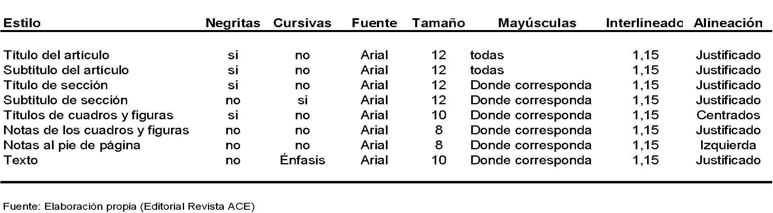
Source: CPSV

1.1 Section subtitle in "Heading 2" style, size 11

This is where the sub-section text begins. Remember that there can only be figures and tables, including graphs, plans, maps, photographs and other graphic material. Remember that footnotes in the text should be at the bottom of the page, not at the end.

"This is a verbatim citation of another author's text published in another document" (Surname, year of publication, p. 25).

Figure 1. Map of a section of Barcelona (size 9)
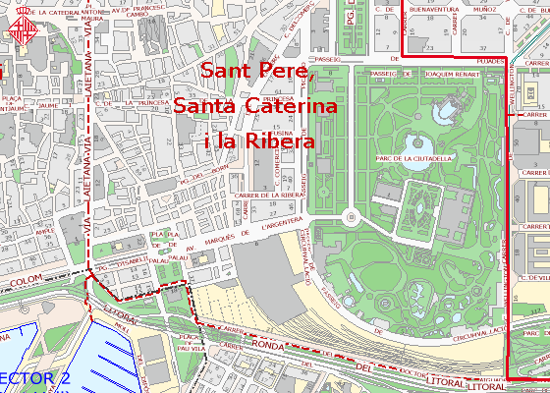
Fuente: Guia Urbana de la Ciutat (Ajuntament de Barcelona) (tamaño 8)

Formulas and/or equations can be inserted using the equation editor integrated in Microsoft Word and will have a number in brackets to the right of them to indicate their order, for example:

(1)

The text continues here.

- Second title, size 11

Paragraph.

2. Conclusions or Final title, always numbered, size 11.

Final paragraph.

Acknowledgements: If this paper is the result of a funded project, it is advisable to include this information in this section.

Conflict of Interest: The authors declare that there is no conflict of interest.

Bibliography

A thorough check will be made to ensure that there is a two-way relationship between the authors who are generically or textually cited in the text and the works cited in the bibliography. Bibliographical citations in the footnotes are not generally allowed, although they may be accepted if all of them are listed in the Bibliography section.

APA style should be used, according to the following examples:

Books
Format:
Author's last name, first initial. (Publication date). Book title. Additional information. City of publication: Publishing company.
Examples:
Allen, T. (1974). Vanishing wildlife of North America. Washington, D.C.: National Geographic Society.
Boorstin, D. (1992). The creators: A history of the heroes of the imagination. New York: Random House.
Nicol, A. M., & Pexman, P. M. (1999). Presenting your findings: A practical guide for creating tables. Washington, DC: American Psychological Association.
Searles, B., & Last, M. (1979). A reader's guide to science fiction. New York: Facts on File, Inc.
Toomer, J. (1988). Cane. Ed. Darwin T. Turner. New York: Norton.

Encyclopedia & Dictionary
Format:
Author's last name, first initial. (Date). Title of Article. Title of Encyclopedia (Volume, pages). City of publication: Publishing company.
Examples:
Bergmann, P. G. (1993). Relativity. In The new encyclopedia britannica (Vol. 26, pp. 501-508). Chicago: Encyclopedia Britannica.
Merriam-Webster's collegiate dictionary (10th ed.). (1993). Springfield, MA: Merriam-Webster.
Pettingill, O. S., Jr. (1980). Falcon and Falconry. World book encyclopedia. (pp. 150-155). Chicago: World Book.
Tobias, R. (1991). Thurber, James. Encyclopedia americana. (p. 600). New York: Scholastic Library Publishing.

Magazine & Newspaper Articles
Format:
Author's last name, first initial. (Publication date). Article title. Periodical title, volume number(issue number if available), inclusive pages.
Note: Do not enclose the title in quotation marks. Put a period after the title. If a periodical includes a volume number, italicize it and then give the page range (in regular type) without "pp." If the periodical does not use volume numbers, as in newspapers, use p. or pp. for page numbers.
Note: Unlike other periodicals, p. or pp. precedes page numbers for a newspaper reference in APA style.
Examples:
Harlow, H. F. (1983). Fundamentals for preparing psychology journal articles. Journal of Comparative and Physiological Psychology, 55, 893-896.
Henry, W. A., III. (1990, April 9). Making the grade in today's schools. Time, 135, 28-31.
Kalette, D. (1986, July 21). California town counts town to big quake. USA Today, 9, p. A1.
Kanfer, S. (1986, July 21). Heard any good books lately? Time, 113, 71-72.
Trillin, C. (1993, February 15). Culture shopping. New Yorker, pp. 48-51.

Website or Webpage
Format:
Online periodical:
Author's name. (Date of publication). Title of article. Title of Periodical, volume number, Retrieved month day, year, from full URL
Online document:
Author's name. (Date of publication). Title of work. Retrieved month day, year, from full URL
Note: When citing Internet sources, refer to the specific website document. If a document is undated, use "n.d." (for no date) immediately after the document title. Break a lengthy URL that goes to another line after a slash or before a period. Continually check your references to online documents. There is no period following a URL.
Note: If you cannot find some of this information, cite what is available.
Examples:
Devitt, T. (2001, August 2). Lightning injures four at music festival. The Why? Files. Retrieved January 23, 2002, from http://whyfiles.org/137lightning/index.html
Dove, R. (1998). Lady freedom among us. The Electronic Text Center. Retrieved June 19, 1998, from Alderman Library, University of Virginia website: http://etext.lib.virginia.edu/subjects/afam.html
Note: If a document is contained within a large and complex website (such as that for a university or a government agency), identify the host organization and the relevant program or department before giving the URL for the document itself. Precede the URL with a colon.
Fredrickson, B. L. (2000, March 7). Cultivating positive emotions to optimize health and well-being. Prevention & Treatment, 3, Article 0001a. Retrieved November 20, 2000, from http://journals.apa.org/prevention/volume3/pre0030001a.html
GVU's 8th WWW user survey. (n.d.). Retrieved August 8, 2000, from http://www.cc.gatech.edu/gvu/usersurveys/survey1997-10/
Health Canada. (2002, February). The safety of genetically modified food crops. Retrieved March 22, 2005, from http://www.hc-sc.gc.ca/english/protection/biologics_genetics/gen_mod_foods/genmodebk.html
Hilts, P. J. (1999, February 16). In forecasting their emotions, most people flunk out. New York Times. Retrieved November 21, 2000, from http://www.nytimes.com

General Conditions

Between 3000 and 4000 words, including bibliographical references, abstract and keywords. The total length shall not exceed 10 pages, including images, if any. The text must be written on A4 size sheets, in Arial 10 pt. font, 1.15 line spacing, with top and bottom margins of 3.0 cm. and right and left margins of 2.5 cm. Only files in Microsoft Word (*.doc), which comply with the format and conditions, will be accepted.

